# **Computer Hardware Identification**

**Date:**

**Group Name:**

**Group Members (2 Max):**

In this activity, in groups of 2, you will be taking a computer apart. Using a working computer and a phone, take pictures of the components and enter a description of the component and what it does. If the computer that is being dissected does not have the component, then getting an image from the internet is acceptable. Identify and describe the following computer components:

1. Case
   * Image: 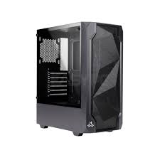
   * Description: big box slightly bigger than a weetbix box witch is made of metal and plastic
   * Function: protect the important parts of the pc
2. Motherboard
   * Image: 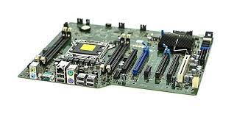
   * Description: large green plate with many metal components
   * Function: it is the vessel of the electrical components
3. CPU
   * Image: A picture containing text, circuit, electronics

     Description automatically generated
   * Description: little green and golden plate
   * Function: the brain of the computer
4. GPU
   * Image: A close-up of a computer part

     Description automatically generated with low confidence
   * Description: a container with a card inside and a fan
   * Function: makes the monitor show things
5. RAM
   * Image: A picture containing text, electronics, circuit

     Description automatically generated
   * Description: green rectangular disk
   * Function: it is the memory of the computor
6. Storage Device
   * SSD vs HDD
7. Cooling
   * CPU
     1. Image: Icon

        Description automatically generated
     2. Description: small fan installed beside the cpu chip
     3. Function: it is supposed to cool the cpu
   * Chassis
     1. Image: 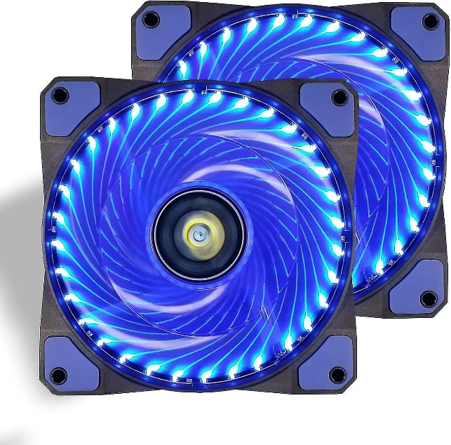
     2. Description: fans on the outer layer of the case
     3. Function: gives air flow through the whole case
8. PSU (Power Supply Unit)
   * Image: 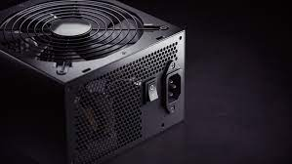
   * Description: a steel box with a fan on top
   * Function: the battery of the pc
9. Monitor
   * Image: 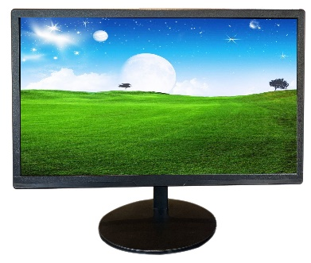
   * Description: a rectangle screen
   * Function: allows you to see what is happening
10. Mouse
    * Image: 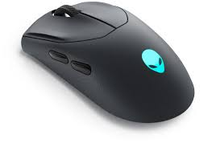
    * Description: a roundish object
    * Function: inputs directions to the curser on screen
11. Keyboard
    * Image: A picture containing text, indoor, electronics, keyboard

      Description automatically generated
    * Description:rectangle with letters on buttons
    * Function: input letters and commands to the pc